***E-DRUG MANAGEMENT SYSTEM for LALIBELA PHARMACY***

***A PROJECT REPORT***

***Submitted by:***

***Name IDNo***

1. ***Fitsum Molla…………………………………....…... TER_0981/11***
2. ***Teklemariam Getnet……………………...…. …..…. TER_1009/11***
3. ***Yirga Eskezia………………….……………. ...….…TER_1013/11***
4. ***Zemete Woldie……………………...…………….... TER_1015/11***

***In partial fulfillment for the award of degree of***

***BACHELOR OF DEGREE IN INFORMATION TECHNOLOGY***

***Under the guidance of***

***Mr. Ketema K. (Ass.prof)***

***…………………..***

***Adviser Signature***



***INFORMATION TECHNOLOGY ACADEMIC PROGRAM***

***SCHOOL OF COMPUTING***

***DEBRE MARKOS INSTITUTE OF TECHNOLOGY***

***DMU, Ethiopia***

***February 2015 E.C***

***Content Page No***

CHAPTER ONE: INTRODUCTION 1

1.1. Introduction 1

1.2. Background of the project 2

1.3. Statement of problem 3

1.4. Objective of the project 5

1.4.1. General objective 5

1.4.2. Specific objectives 5

1.5. Scope of the project 5

1.6. Significance of the project 6

1.7. Tools and methodology 7

1.7.1. Data collection Methodology 7

1.7.2. Programming language to be used 9

1.7.3. System requirements (Hardware and Software) 10

1.7.4. System Modeling Tools 11

1.8. Feasibility study 12

1.8.1. Technical Feasibility 12

1.8.2. Operational Feasibility 13

1.8.3. Economic Feasibility 14

1.8.4. Legal Feasibilities 16

CHAPTER TWO: SYSTEM ANALYSIS 17

2.1. Overview of the Existing System 17

2.1.1. Actors and use cases on the existing system 20

2.1.2. Business rules on existing system 20

2.2. Overview of the Proposed System 21

2.3. System Requirement specification 22

2.3.1. Functional Requirement 22

2.3.2. Non-functional requirement 24

2.4. Business Rule Identification 26

2.5. System Requirement Analysis 27

2.6. Actor and Use case Identification 28

2.7. Use case Diagram 31

2.8. Use Case Diagram Description 32

2.9. Sequence Diagrams 36

2.10. Activity Diagrams 40

2.11. Analysis Class Diagram 44

CHAPTER THREE 46

3. SYSTEM DESIGN 46

3.1. Design Class Diagram 46

3.2. Physical Data Model 47

3.3. User Interface Design 49

3.4. Deployment Diagram 53

References 55

List of Tables

Table 1.8.1: The cost their expense with in manual system maybe within monthly 15

Table 1.8.2: The cost we expense when we use E-drug system 15

Table 2.6.1: Use case identification table 30

Table 2.8.1:Use case description for login 32

Table 2.8.2: Use case description of read detail description of drug 32

Table 2.8.3: Use case description for register drugs 33

Table 2.8.4: Use case description for Add drugs 33

Table 2.8.5: Use case description for view report 34

Table 2.8.6: Use case description for send drug issue 34

Table 2.8.7: Use case description for accept/reject order 35

Table 2.8.8: Use case description for accept money 35

Table 2.8.9: Use case description for manage account 36

List of Figures

Figure 2.7.1: Use case Diagram 31

Figure 2.9.1: Sequence diagram for login page 37

Figure 2.9.2: Sequence diagram for create account 38

Figure 2.9.3: Sequence diagram for add drug 39

Figure 2.10.1: Activity diagram for login 41

Figure 2.10.2: Activity diagram for create account 42

Figure 2.10.3: Activity diagram for add drug 43

Figure 2.11.1: Analysis Class Diagram 45

Figure 3.1.1: Design Class Diagram 47

Figure 3.2.1: Physical database table of User 48

Figure 3.2.2: Detail of drug information on the database 48

Figure 3.2.3: Order of drug and its database basics 49

Figure 3.3.1: Homepage of User Interface Design 50

Figure 3.3.2: Login Page for Users 51

Figure 3.3.3: Add drug user interface on System 52

Figure 3.3.4: Order drug from pharmacy using browsers 53

Figure 3.4.1: Deployment Diagram for E-Drug Management System 54

Acronym and Abbreviations

***BR***: Business Rule

***CD***: Compact Disk

***DB***: Database

***DMS***: Drug Management System

***DS***-: Drug Store

***E-drug***: Electronics Drug

***GUI***: Graphical User Interface

***HDD***: Hard Disk Drive

***HTML***- Hypertext Mark Language

***OOA***: Object Analysis Design

***OOD***: Object Oriented Design

***OOSD***: Object Oriented Software Development

***PHP***: Hypertext Preprocessor

***RAM***: Random Access Memory

***SQL***: Structured Query Language

***UC***: Use Case

***UML***: Unified Modelling Language

Definition

***Documentation***: is a material that provides official information or evidence or that serves as a record.

***E-drug:*** means to manage the drug in an automated way for convenient system development.

Interview: is a meeting of people face to face especially for consultation.

***Observation***: is the action or process of closely observing or monitoring something or someone.

***Tracking***: a line or route along which something travels or moves.

# CHAPTER ONE: INTRODUCTION

# Introduction

Recently, technology plays an important role in all management scope in order to computerize most people's jobs in an effective manner. Besides, the management of the paper base services faced several complications in a specific direction that can be summarized intime are lost in tracking, matching or storing documentation in manual procedures.

In 2010, Nurul Muhammed proposed a Drug Management System (DMS) that would increase the stocktaking management process. The proposed system is equipped with an alarm that alerts the admin about all medicines which have reached the minimum quantity and medicines that expired [1].

In 2012, Carlisle George presented in his book different algorithms with rich information about issuing drugs and monitoring and controlling patients [2].

In 2017, the authors proposed a first elementary approach to sort the services of the most important Hospital Departments under the light of the disrupting influence of the emerging IoT [3].

In 2018, the author presented a study that describes the current situation touching all the related portions to the hospital pharmacies functions [4].

In this work, an e-drug management system for Lalibela pharmacy based on a database and designed GUI frames has been presented. The included information regarding the patients or customers and medicines as well as the inpatient and outpatient related information are stored in the built database. The presented system is divided into: patient registration, inpatient, outpatient and medicine. This is because in hospitals there are two kinds of patients: inpatient, and outpatient. Each of the above parts includes different types of actions and database tables in addition to GUI frames for managing.

Drugs are the chemical substances that are administered to patients for curative purposes and prophylaxis. It can also be known as a medicine, because it is the essential part of people’s care.

The ability of the computer to store and retrieve information at a very fast and  
efficient rate makes its application useful in management operations. Drug management in Lalibela pharmacy involves drug procurement, drug distribution, drug tracking and its information management on the pharmacy. Drug distribution is concerned with distribution of drugs within the different medical units or departments in pharmacy, while drug procurement is concerned with the purchasing activities of the drugs by the pharmacy department of the drug stores. In the same vein, drug tracking is concerned with the continuous monitoring of the actual quantity of drugs held in the pharmacy or any other drug warehouse/store. It also controls the stock level pharmaceutical unit in Lalibela pharmacy and is concerned with drug management activities. They carry out the responsibility of making appropriate selection and drugs used by formulating an annual, monthly, weekly or daily list of drugs requirement and management reports. However, in some pharmacy today, some pharmacists still use the manual system of operation which can lead to inappropriate drug management errors due to problems of handling voluminous file within a short period of time. This could make data to be easily inaccessible and also delivery of drugs can lead to misplacement of patients’ files.

# Background of the project

The electronic drug management systems are considered as a computer system which are used to manage and store the medicines in pharmacies. These systems replaced the manual systems with highly efficient functions such as: stock management and control, medicine labeling, knowing the medication history of the patient and supporting the process of pharmacy.

Generally, electronic technology has been implemented to automate the traditional systems. So, different copies of management systems in different scope were presented. These systems include the services provided to companies as well as people, such as pharmacy. The traditional data management system for pharmacy as example, suffers from the capacity, time consuming, medicines accessibility, managing the medicines store as well as the need of qualified staff according to the requirements of employer expectations. In this paper, a pharmacy e-drug system is proposed in order to facilitate the job, out of the mentioned problems. A data management system to the Lalibela pharmacy sites is proposed which is divided into two main parts: database, and Graphical User Interface (GUI) frames. The database built using SQL Server contains the pharmacy information related to the medicines, patient information…etc. the GUI frames ease the use of the proposed system by unskilled users. Lalibela pharmacy found in EastGojjam Zone Debremarkos town near Gozamen Hotel Eseynesh building on the exit of Bahir Dar Street. Lalibela pharmacy was established in 2012 E.C for the purpose of providing various medication and drug selling for the community live around the town and the persons need the drugs. The pharmacy give thee service for a community and have get the award from the health bureau have given vital and convinced service for the community with in full effort of providing the drugs. They have been giving the service for the community and their work environment facing the problem on the way of giving service. The proposal system is responsible for monitoring and controlling the work of pharmacies in hospitals in terms of management of medicine, issuing ordering and hospital medical reports.

When we initiate to do this project, the project comes different convenient usage of system on drug procurement, drug management, drug tracking and drug distributions in Lalibela pharmacy information management system.

This project which is drug procurement and distribution tracking system provides a  
computer-based information management system in a Lalibela pharmacy drug stores by designing a cost-effective, user-friendly application, incorporating key attributes of data integrity  
and system security suitable for use in the drug stores of the pharmacy in developing the database and visual basics as the programming language. The overall aim of this project is to optimize time and material in the processing of data needed for effective operation of large pharmacy. By this approach, data integrity, data redundancy, and consistency will be ensured.

# Statement of problem

Drug procurement, tracking, distribution and information management in this regard are routine processes carried out in pharmacy. It is a common place to observe that these routine processes are still performed manually or are minimally computerized even in large pharmacies. This manual approach to these routine operations has a lot of problems associated with it, ranging from poor handling of drug data of patients, lack of good storage information management system for drugs and drug dispensaries, delays, to the difficulty in retrieving information on drugs and customers records. In view of all these problems, it becomes necessary to develop a computer-based drug information management system and distribution tracking system for Lalibela pharmacy. This is what this research project is set to address by computerizing the routine processes in pharmacy and in particular drugstore on the pharmacies. The main problems challenged on the working environment

**Pharmacies:**

* Lose too much time when getting the workload to find the drug on easiest step of finding pharmacies.
* Difficult to manage and control daily activities.
* Don’t have the expired date alerting mechanism to facilitate the working environment.
* Staff members should arrive at working place to conduct anything related to pharmacy.
* It should require a paper format to register a drug and it is too bad for pharmacy on handling the drugs detail.
* They expense more for promotion of their working place and the task they have given.
* Managers prepare report manually about the selling and buying activity and further tasks like handling the working activity of pharmacy for daily, weekly, monthly and annually.

**Patients/customer’s: -**

* Can’t check the availability of drugs at the nearest pharmacy when we are sitting in our room in case of this expense money for finding and obtain the drugs on location tracks.
* The drug we want hasn't been found in the city; the customer doesn’t know the availability of drugs in the nearest city location. We can find the drug beyond their city.
* Expired date is the main challenge for customers because it is not checked within an automated system.
* Lack of enough information about medicines include manufacturing issue and ingredients.
* There is no fast and efficient way of getting information about drugs in the drug store.
* Can’t compare the price tags of drugs within the pharmacies from one to the other.
* Patients must arrive on the pharmacy to get the drug.

So, to solve the above problems we will develop electronics drug management system for Lalibela pharmacy.

Our project item proposed the solution for existing system to make the customer access and services easy and to get any information and services regarding with their location by using their own device such as desktop computer, personal computer, mobile phone etc. This solution is somewhat used to minimize time, cost. The solution that we proposed is as follows:

Develop Mobile Application: If it is developed by using android application it more important and the best one but due to programming language limitation the team members are not completely agreed on this solution. So, it is selected PHP by our team members integrated with android application.

Develop Web based Application Using English Version and developed by using **PHP** with in integrated of android so we select this solution than others.

**Alternative solution**

Develop Web based Application Using English Version and developed by using **PHP integrated with Android** and the user interface is clear for all users.

# Objective of the project

## General objective

The main objective of this project is to be develop web based integrated with mobile based an electronic drug management system for Lalibela pharmacy.

## Specific objectives

To achieve the general objective mentioned above the following are specific objectives:

* To register the drugs and customer information.
* To alert the expired date of drugs.
* To check the availability of drugs on the pharmacy.
* To compare the price of drugs from one pharmacy to another.
* To help the customer locating the tracking system of pharmacies.
* To secure the information of customers for privacy.
* To generate reports about daily, weekly, monthly and annual working activities.
* To take backup of the system and restore when it will be necessary to them.
* To improve the accuracy and increase the safety and efficiency of the pharmacy store.

# Scope of the project

Project scope is a way to set boundaries on our project and define exactly what goals, deadlines, and project deliverables we will be working towards.

***Geographical boundary***: geographically the system is limited to Lalibela pharmacy which provides service of medicine procurement and distribution after the drug is available on the pharmacy.

***Functional boundary***: the proposed project had functionality listed.

Scope of project performs as:

**Scope in:**

* Managers direct and manage staff workers far from the working place.
* Registering the drug on the pharmacy.
* Manage data about drug information and its daily activity or selling condition.
* Generate reports about drugs and working activity.
* Tracking the pharmacy’s location.
* Posting or uploading new things when its more urgent or useful.
* Alerting the expiration date of drugs near to dispose or out of using.

**Scope out: -**

Our proposed system will not be done following activities on project boundaries.

* The payment system is not included on the system and may use current payment systems like tele birr and CBE birr.
* The system covers only pharmacies i.e., this means where the drug comes from and the supplier of drugs for pharmacies are not included on this. Therefore, the system covers the activities from pharmacies to customer relationships.

# Significance of the project

This project focuses on the specific conditions of the drug store that is drug registration and procurement management system. The newly developed electronic drug management system can lead pharmacies into computerized systems. Its significance is: -

E-drug management systems sharply improve the searching speed of sellers and client’s details for the user to insert keywords to search drugs. Besides, sellers can benefit because it manages the booking of medicines by showing available drugs for clients and always records every single drug to easily report the company. So, sellers can print the report. Cashier also does not have to calculate the profit for the manager because the system will produce reports. E-drug also removes the problem of how to get the medicine and where we can get it, the distance traveled to take/find the drugs, and queuing up of customers and staff during processing activity. And it is very convenient to use it right from the staff/seller, office and anywhere they are due to this is used to reduce costs such as labor and stationary.

***Target beneficiary of the system are: -***

***For customer/patients:***

* Reduce wastage of time to get drugs and reduce resource consumption.
* Tracking the location of pharmacy to acquire the drugs they want.
* To get information about drugs within detail and widely.
* Check the expired date of drugs and drug types.
* Obtain the drugs far from the pharmacy with in the conduction of communication.

***For pharmacies: -***

* Effective and efficient management of drugs in the center.
* Helps to harmonize strong management in the pharmacies.
* Control the activity of drug management including cashiers and pharmacists.
* Make the service delivery process fast and make its data accurate and secure.
* Improve their working quality learn from seeing the customers want.
* Reduce errors and avoid data entry error on the system
* Reduce the workload and save time when they register the drugs.
* Make the drugs available for selling.
* Help to generate reports about selling and buying drugs beside the data about customers want like which drugs have been sold.

***For team member: -***

* In addition to the above, the system is useful for the team members to get bachelor degrees from the department of information technology and get experience from the working environment of the project.

# Tools and methodology

A methodology is a set of methods, processes, and practices that are repeatedly carried out to deliver projects. Some of the methodologies that the team members used to gather information about the drug stores were listed below.

## Data collection Methodology

The method to be used for achieving the development of this project is based on the need of getting appropriate information related to the drug store health centers.

For the purpose of getting appropriate information, we used the following types of data gathering methodologies including Interview, direct observation, and document analysis***.***

***Interview:***

It is a fact-finding technique whereby the system analyst collects information from individual face to face interaction.

It gives an opportunity to motivate the interviewee to respond freely and openly and it allows us to provide more feedback from the interviewee. In addition, we believe that we adapt reward questions for each individual. Having an interview, making questionnaires and observing the around problems. Also, we will collect raw data or documents which are useful for the project should be implemented.

We interviewed sister Menbere from Lalibela pharmacy near Gozamen Hotel and she replied they had faced a challenge on this field because of a customer far from technology and she added with in this reason not wanted using automated way and if they can get the chance to use automated system happy to use for using this system for storing drugs.

When we interviewed the pharmacy staffs and their customers or patients get the service from the pharmacy collect the data like:

* Customers said tiredness of getting the drug from the pharmacies and waste too much time.
* Patients paid the price of drugs they have asked.
* Pharmacy staffs fussing to do the working activity.

***Document analysis:***

To get more information about the project we used earlier documents that help us to develop this project. During the analysis of documents, we considered those documents which can bring more features to the project relevant to develop the proposed system. Besides, we have seen the working environment of pharmacies on the documented files and those files gave us detailed information about how the current system runs manually and the turning point for intention of doing something widely.

***Observation:***

We have seen customers queuing to get service, pharmacists challenged to get the drug from the store and puzzled on if it has or not. Besides, the cashier had faced the problem of prices and calculating the amount. Like, to get the drug and ask if the drugs have or not. By observing the current environment of drug stores in different places like Shebel pharmacy, Markos drug store, Worku drug store, Lalibela pharmacy. We collect data which are necessary for automated the existing system.

## Programming language to be used

In order to implement our system, we will use these software program tools to develop our system.

1. JavaScript: - JavaScript is a very interesting language used to validate data and develop different messages. We will validate our data which we used in html code.
2. PHP, android, java- Is used to develop or create a dynamic website, and for making dynamic and interactive web pages quickly.
3. HTML: to describe web pages.
4. We will use Other related software when we need to develop some interfaces.

***Front end selection:***

* It must have a graphical user interface that assists the employee involved on the system.
* Must be according to organization requirements and the business rule.
* Must provide excellent reporting features with good printing support.
* Platform independent.
* Front end must support some backend programs like MySQL.

According to the above stated feature we select JavaScript, HTML android and CSS as the front end.

***Backend selected:***

* Multiple user support
* Efficient data handling.
* Provide an efficient security system.
* Efficient data retrieval and maintenance.
* Operating system compatible.
* Easy to install.
* Easy to debug and maintain.
* Easily connect to the frontend.

According to the above stated features we selected MySQL server, PHP the backend. And to implement the automated system there must be network infrastructure within different offices of the vital event registration and one dedicated server.

## System requirements (Hardware and Software)

***Hardware requirement:***

To implement our document, we will use the following hardware devices.

Personal computer: laptop and desktop computer.

Connection cable or ethernet cable to find the information we want and useful for doing a project.

Printer: we used it for printing software files to get the hardware document.

Intel(R) Core(R)i5 CPU N2830 @ 2.6GHz

RAM (Random Access Memory) (4GB)

Electronic cameras: to capture different images.

Flash disk(32GB): to save (store) files.

Compact disks: for backup purpose.

***Software requirement:***

Software is a program that enables a computer to perform a specific task, as opposed to the physical components of the system (hardware). To implement our document, we used the following software.

Apache Web server: is software that will be used to run Server-side applications.

PHP, Java, Android**:** hypertext preprocessor language. It will be used to implement the server-side sub system of the system.

Visual studio, Dreamweaver and Notepad++: Used to write the specific code.

Microsoft office word 2019 (For writing documentation)

Microsoft PowerPoint 2019(For presentation).

Windows 10 pro Operating system.

Visual paradigm and wonder share edraw max, proto.io: For drawing UML diagrams and user interface diagrams.

## System Modeling Tools

The team plan to use the Object-Oriented Software Development Methodology (OOSD) for the

development of the system among the different methodologies. Because it is better way to

construct, manage and assemble objects that are implemented in our system. We used OOSD

because of the following important features:

* **Increased extensibility: -** when you need to add a new feature to the system you only need to make changes in one part of the applicable class.
* **Financial benefits**: - reusability, extensibility and improved quality are all the financial

benefits, because they led to the business benefits of the object- oriented from the point of

viewing the users, the real benefits are we can build systems faster and cheaper. reduced

maintenance cost of Software organizations currently spends significant resources maintain

operating system so the object-oriented development methods help us to overcome this

problem.

* **Improved quality**: - quality of our system is on time, on budget and meets our exceeded the

expectation of the users of our system, improved quality comes from increased participation

of users in the system development. So, our system has improved quality since we are using

Object Oriented methodology. We, the project team selects Object oriented design

methodology to use Unified modeling language for analysis and design method.

Object oriented design methodology has **two** phases: -

* **Object Oriented Analysis (OO*A):*** During this phase the team used to model the

function of the system (use case modeling), find and identify the business objects,

organize the objects and identify the relationship between them and finally model

the behavior of the objects.

* **Object Oriented Design (OOD):** During this phase the model interactions and

behaviors that support the use case scenario, and finally update the object model to reflect the implementation environment. And also transforms the conceptual model produced in object-oriented analysis to take account of the constraints imposed to our system format, so that we will use this phase to refine the use case model to reflect the implementation environment. An object-oriented system analysis and design methodology suitable for this particular project because: -

* It reflects reality more accurately.
* It highly reduces the semantic gap between the reality and models
* Object oriented system analysis and design methodology is more user friendly
* Supports reusability and encapsulation: -
* Increase reusability: - the object oriented provides opportunities for reuse through the concepts of inheritance, polymorphism, encapsulation and modularity
* Users usually understand the objects easily.
* Reduce complexity.

# Feasibility study

A feasibility analysis involves a detailed assessment of the need, value and practicality of a proposed enterprise, such as systems development. The process of designing and implementing recordkeeping systems has significant accountability and resource implications for an organization. Feasibility analysis will help us make informed and transparent decisions at crucial points during the developmental process to determine whether it is operationally, economically and technically realistic to proceed with a particular course of action.

Most feasibility studies are distinguished for both users and analysts. First, the study often presupposes that when the feasibility document is being prepared, the analyst is in a position to evaluate solutions. Second, most studies tend to overlook the confusion inherent in system development – the constraints and the assumed attitudes.

## Technical Feasibility

Technical feasibility is the measure of the practicality of a specific technical solution and the availability of technical resources. In technical feasibility we should notify that our system can implement with current technology and also the system user has enough experience using that technology. Technical feasibility addresses three main things:

* The system will be done with little experience about technology study and not required external training for customers.
* It is better and easier to use current advanced technologies and the user can be using on convenient terms.
* The ability to use the technologies that can support the internet is practical for this system.

The system would be developed by using technologically system development techniques such as PHP, android, Java Script, CSS and MySQL database without any problems. When we evaluate the hardware’s and software requirement and how they meet the need of the proposed system, our proposed system is technically feasible because we are using currently available and affordable technologies to develop the proposed system easy user interface to access.

## Operational Feasibility

Measure how much the proposed system solves the existing system problems. This project is surely operationally feasible because the system (the project) is a good solution maker of the problem and creates a good environment towards the user of the system by providing easy, user interactive and everywhere access.

It is mainly related to human coordination and political aspects. The points to be considered are:

* The system operates on the pharmacy and give provided services for customers with in little required fulfillment of materials and pharmacies operate reduce workload of customers and staff members
* Update the system when the customer is not satisfied on the system and operate easily on the environment from the required query of customers.
* The pharmacies operate the system with in ease environment for customers

The system is operationally feasible as it is very easy for the End users to operate. It only needs a basic computer system. The customers can operate the system with little training. The system is developed using English languages, may be to include Amharic language and a Help menu will also assist customers to easily interact with the system. So, we can say that the system is operationally feasible.

## Economic Feasibility

Is the process of identifying the financial benefits and associated with development of the

proposed system (project). This feasibility is the resource saving ability specially cost-benefit

analysis. The newly developed system provides many benefits to the society and the pharmacy drug store.

The newly developed system improves the time gap, access of property and saves resources.

* Cost estimation
* One time cost
  + The cost to buy a server computer.
  + The cost to buy client computers and network connection.
  + The cost paid for system designers and system analysis.
  + The cost of software to be acquired to build and run the system.
* Recurring cost
  + The cost to train sellers and buyers how to use a system.
  + The cost to maintain computers if there is a problem with computers.
* Benefit estimation
  + - ***Tangible benefits:*** are those our project benefits that can convert into monetary values. E.g., reduced stationary cost

***The expense of money when we are using the manual system.***

|  |  |  |
| --- | --- | --- |
| Materials need expense | Amount within birr and its quantity | Total cost we expense |
| **Pharmacies** |  |  |
| 1. Print paper | 100*1.5 | 150 |
| 1. Printer color | 800*10 | 8000 |
| 1. Storage boxes and pens | 500*2 | 1000 |
| **Customers** |  |  |
| 1. Transport for finding pharmacy | 100 | 100 |
| 1. Buy the drug when we find first | 500 | 500 |
| Total cost |  | 9750.00 birr |

Table 1.8.1: The cost their expense with in manual system maybe within monthly

***The cost we expense when we are using this system***

|  |  |  |
| --- | --- | --- |
| The fields cost reduce within this project | How many percents reduce using this system (%) | Total reduce cost |
| **Pharmacies** |  |  |
| 1. Printing paper and pen | 50% | 150*0.5=75 |
| 1. Printer color | 50% | 8000*0.5=4000 |
| 1. Storage boxes | 50% | 1000*0.5=500 |
| **Customers** |  |  |
| 1. Expense for finding the pharmacy | 95% | 100*0.95=95 |
| 1. Compare the price of drugs from one pharmacy to another | 20% | 500*0.2=100 |
| Total cost the system reduces |  | 4770.00 birr |

Table 1.8.2: The cost we expense when we use E-drug system

When we use this automated system, we can reduce the expense of money to extra unwanted activities like transport fees, buy the drug on expensive price tags and paperwork. So, we have seen from the above table that the expenses on automated systems reduce more than 50 % expenses from the automated system. Notice the above table, the cost reduces from 9750.00 birr within 4770.00 birr from the total cost of their expense.

When we use this system, we need a number of computers and smartphones for accessing it and incase of this, we spend a large amount of money purchasing these materials. But we purchase these materials once to give service for a long time.

1. ***Intangible benefits:*** are those our project benefits that cannot convert into monetary values.

E.g., knowledge gain by project developer, increasing the competitiveness of the

individual, timelier, updated, and accurate information, better drug information

management

* The organization will be happy because there are no difficulties while

announcing properties and manual documented, and also, delivered from

wastage of money.

* The buyers/sellers will be happy because their time is saved by the system.
* Buyers get satisfaction and free working space from the system.
* Knowledge gained by project developers.
* Increasing the competitiveness of the pharmacies advertise themselves...
* Improved productivity.
* Improving the morale of our team.
* Facilitating information processing of our team.
* Faster decision making on the team member.

All the above points are the benefits of our system. So, we conclude that the estimation of benefit

is greater than cost estimation. Therefore, our system is economically feasible.

## Legal Feasibilities

The system to be developed does not conflict with any health ministry rule and regulations, because it gives services for the people effectively and efficiently so the organization is profitable and the system is politically feasible.

The system we will develop should respect a rule and regulation about pharmacy guidelines about how to distribute and give the information to customers when we use the medicine and expiration date of the drugs.

# CHAPTER TWO: SYSTEM ANALYSIS

Systems analysis is a problem-solving method that involves looking at the wider system, breaking apart the parts, and figuring out how it works in order to achieve a particular goal. But before we get into detail about how that works,

System analysis is a procedure or approach that serves to determine the system’s performance for a given (known) structure of this system.

This section deals with analyzing the general workflow and its major players or participants of the existing system. It produces a broad outline of the system that identifies the function to be performed and the technical aspect that the system must fulfill and briefly describes the existing system functionality, problem of the existing system. It also deals with the functional and non- functional requirements of the proposed system.

The system analysis model deals with analyzing the system and modeled using UML (Unified Modeling Language) models for representing this analysis. It includes the system use case

diagrams, the use case descriptions (scenarios), sequence diagrams, activity diagrams, analysis

class diagram. After identifying the actors and use cases, the use cases are developed and textual

descriptions (scenarios) are stated. The Sequence diagram is depicted based on the use cases

which are developed for the system. Activities will be represented by the activity diagrams. The business rule is also identified here.

# Overview of the Existing System

We study the background of the system from the above and the system is not working on the pharmacies in our country pharmacy drug stores. Generally, the overall activities of existing systems include the drug information management of pharmacies and reaching the customer’s needs. Then pharmacists ask some questions about her/his diseases or the commanding paper from the hospital or private clinic’s and what he/she wants from the pharmacy. When we want some medicine from the clinic or some pharmacies, we can't get any of the drugs we need. The information about drugs is not adjusted in a convenient way to obtain it easily and its expiration date is not recognized in real time. The pharmacists should assist the customer about how to use and when they are not pinned fully matched. The prospect of medicine on the governmental health service provider centers and private clinics with in facing a problem some drugs not present from these centers because of the data are not sit on the automated way.

*Report preparation and generation*: In the existing system is being prepared in the form of paper documentation from the work done either by pharmacist, pharmacy manager or other employees. These paper document reports are prepared by the following employees:

* Report prepared by Pharmacist:

The pharmacist prepares the following reports:

* How many drugs are there in each store? How many of them are sold and how many of them are available?
* The details of drugs (their number, type, cost…)

In the existing system drug registration is done manually which is time taking, exhausting and has no accuracy. The whole document is stored using file cabinets and a suspension filing system for a long period of time. This makes it overcrowded and easy to damage. Generally, the existing system faces a lot of problems, and these problems result due to the manual system of accomplishing its operations. Such as:

* Performance
  + Doing activities using manual document results week performance
  + Is time consuming
* Information (and Data)
  + Outputs
* Lack of any necessary or relevant information
* Too much information – information overload
* Information that is not accurate
* Information that is not timely to its subsequent use
  + Inputs
* Data is not captured in time to be useful
* Data is not accurately captured – contains errors
* Data is difficult to capture
* Data is captured redundantly – same data is captured more than once
* Too much and/or illegal data is captured
  + Stored Data
* Data is stored redundantly in multiple files
* Data is not secure from accident or vandalism (because data is stored in paper)
* Data is not well organized
* Data is not flexible – not easy to meet new information needs from stored data
* Economics
  + Costs
    - Costs are too high (needs too much resource like employee and paper)
  + Control (and Security)
* Too little security or control
* Input data is not adequately edited
* Crimes (e.g., fraud, theft, embezzlement) are (or can be) committed against the data
* Ethics are breached on data or information – refers to data or information getting to unauthorized people
* Redundantly stored data is inconsistent in different files or databases
* Processing errors are occurring by people.
* Efficiency
  + People waste time
    - Data is redundantly input or copied and processed.
  + waste drugs and manpower
    - Effort required for tasks is excessive (too much workers)
    - Holdings required for tasks is excessive (e.g., paper)
* Service
  + The Existing system produces inaccurate, inconsistent and unreliable results
  + It is not easy and awkward to use
  + It is difficult to coordinate with other systems

Based on the analysis investigated so far, the problems of the existing systems are stated.

## Actors and use cases on the existing system

The existing system has an actor and use cases that provides a service and facilitates a conducting of Lalibela pharmacy selling of drugs and implementing a manual process of doing activity. And the existing system has activities that are implemented in the pharmacy for easing the process.

Actors involved on the existing system and their uses cases:

Customer:

* require drugs
* see drugs detail
* see price tags
* pay money

Pharmacist:

* Give detail information about drug
* Ask patients required information
* Give drug to patients
* Check detail about drugs

Manager:

* Prepare report
* Observe working environment

Cashier:

* Receive payment
* Calculate daily finance issue

From the above description we understand the system is implemented in a manual way and it is consuming time and increasing the workload of staff and system admin is not involved on this existing system.



## Business rules on existing system

Business rules are directives that define an organization’s business activities. They are important because they clarify an organization’s objectives and detail how processes will be performed. Business rules can be informal, written, or automated.

BR1: Pharmacies that are governed by defined business rules or internal policies.

BR2: Pharmacies seeking to improve efficiency while making more informed decisions.

BR3: Pharmacies that are concerned about compliance issues and want to reduce the possibility of legal and regulatory actions.

BR4: Pharmacies that prioritize flexibility to adapt to changing market conditions.

BR5: Patients should have their drug ordering paper from the legal Healthcare center.

BR6: The expired date of drugs should be pinned correctly on the drug packs and pharmacists sell only legally checked drugs to customers.

BR7: Patients should submit medical report papers or treatment evidence from the doctor.

BR8: Pharmacies should secure the privacy of customers and only use them for data manipulation.

# Overview of the Proposed System

The proposed system will reduce the existing system problems which usually occurred in pharmacies drug management systems. Proposed system is to improve some activities through a computerized way that simplifies the workload of the existing system and speeds up the operation of the system. The new system pharmacies perform electronic drug management systems and promote themselves on the system to facilitate the selling of drugs. The pharmacies register the drugs, update the information about drugs, and sell the drug within the system. Proposed system is a system which avoids more manual work time that needs to be spent recording and keeping the data in a centralized way which is available to all the users simultaneously. It is very easy to manage useful data in a database. They can easily use the system to decrease manual hours spent for normal things and hence increase the performances.

Generally, the proposed system has advantages because it is easy to manage all the daily transactions, can generate required reports easily, easy to manage historical data in a secure manner, centralized database helps in avoiding conflicts and easy to use GUI and use android application on our phone that does not require specific training.

# System Requirement specification

The System Requirements Specification (SRS) is a document focused on what the software needs to do and how it must perform. It lays the important groundwork so that every person involved with the project understands the most crucial details.

An SRS outlines the behaviors, [functions,](https://www.jamasoftware.com/requirements-management/functional-requirement-vs-non-functional-requirements/) and capabilities required of the system, along with any potential constraints and required useful data gather. [Functional](https://www.jamasoftware.com/requirements-management/functional-requirements/) and [nonfunctional](https://www.jamasoftware.com/requirements-management/non-functional-requirements/) requirements are included. Design suggestions and information outside the customer’s requirements are not included.

Approval is received from all necessary stakeholders, showing that they clearly understand the project requirements and everyone agrees. In a sense, the SRS functions as an insurance policy that any party can refer to in case of uncertainty.

Using an SRS ensures that specifics around a project are crystal clear, reducing the risk of rework and wasted time. Important benefits of using this type of document include:

* Providing valuable customer feedback.
* Breaking work into smaller pieces
* Serving as a parent document

A well designed, well written system requirement specification accomplishes four major goals:

* It provides feedback to the system.
* It decomposes the problem into component parts.
* It serves as an input to the design specification.
* It serves as a product validation check.

System requirements may be either functional or nonfunctional requirements.

## Functional Requirement

A functional requirement is a statement of what a product (system, subsystem, system component, device or software program) must do.

The new system is expected to provide the following functionalities:

* Input Requirement
  + - Store drug information
    - Each input item information must include drug id, drug name, code, quantity, manufacturing company, and expiry date.
* Output Requirement
  + - The system displays a report for the pharmacy manager.
    - The system should store all the data related to all the tasks performed into a database.
    - Display store drugs that have reached the expired date.
    - When there is no drug in the store the system responds to the low stock drugs.
    - Test and evaluate the performance of the proposed system by inserting different data.

Generally, our system has the following functionalities:

* Registration; the system shall register drugs
  + When the pharmacies register the drug, we should handle the next systematic issues like updating and disposing activity of registered drugs.
* Authorization: users can register to system for doing activity and see the drugs login the system, including pharmacy manager and pharmacist.
* Authentication; The system shall authenticate users to identify who is the right user.
* Generating Report; The system should report about each drug.
  + Reports managed on the time interval of daily, weekly, monthly and annual generating of report for facilitating the working environment of pharmacy to improvise their quality giving of service.
* Manage drug detail; The system should register, update information and delete drugs.
* Manage order detail; The system should register, update information and facilitate the ordering activity of drugs in the pharmacy.
* View post: Employees of the pharmacy can see any post about pharmacy working activity.

## Non-functional requirement

A **non-functional requirement** is a statement of what a product is or how it will be constructed, or a constraint on how the product will be designed or will behave.

Non-functional requirements state constraints on the design and construction of the product. They are often dictated by contractual or regulatory requirements, which may include, among others:

* In-service support requirements

Non-functional requirements are not often decomposed into more detailed requirements. They are typically verified by inspection of the product and its documentation. Non-functional requirements will be mandatory if dictated by contractual or regulatory requirements. They may not be mandatory, however, if dictated by marketing goals or other internal objectives, as often occurs in consumer product development.

**The following are non-functional requirement:**

* **Performance or Response**

Responses to search information and to generate information should take no longer than a few seconds. To improve a web page's performance

* We will minimize the number of round trips that the browser needs to make to the server. Every file that our website includes (such as CSS, JavaScript or images) all will be downloaded to the browser.
* By properly formatting and compressing images without losing their look or visual quality we will save the size of data that needs to be downloaded, resulting in beautiful optimized images for the web.
* **Security and access permission**

The system will use a secure database by granting privileges for the user based on the role every user will have to log in before to operate on the system. In addition to this:

* Authentication; The system shall authenticate users to identify who is the right user.
* Sensitive data will be encrypted with in MD5 for the privacy of customers about personal profile and the information about what the customer is ordered.
* We don’t rely on the user interface alone, make sure there is protection on the back end at the function level
* Data input from users will be properly validated or escaped to prevent the injected code from being effective on a server.
* **Backup and Recovery**

To maintain recoverability, we will have

In addition to authorizing access to users, the system could have problems in such

areas of data drugs, sold drugs, and human errors. For this purpose, incremental backup copies

(Copies of only the challenge to files) and full backup copies (copies of all files) will be made

and stored in a secured location.

* The system should to take the backup to store the urgent data for future tasks operation.
* Backup system that can mitigate the effects of data loss, which is necessary to achieve recoverability and, therefore, aids availability in the event of data loss will be applied.
* Good recovery plan for a server failure with list of the steps that we took to perform our initial server deployment, with extra procedures for restoring application data from backups in addition to good and descriptive documentation will be used
* **User interface**

The system should be usable for the user by short period of training and it should help users to eliminate difficulties and to do this we use techniques:

* We will have good Background Color, Texture and Contrast
* We will have good navigation
* Effortless usage with minimum number of clicks
* To help users not to get our application tiresome we will use techniques such as
* Limited scrolling – be it horizontal or vertical
* Making it easy for your users to accomplish their tasks such as
* Not asking users to fill unnecessary, lengthy forms
* Making sure that users are able to identify links and call to action buttons easily
* Highlighting new arrivals or important products or services on the page so that your regular visitors can find them with ease
* **Reusability**

Portions of the system can be used for the development in another related system. To make our application reusable we will use the following techniques

* Making a class/method do just one thing.
* Removing single business logic or main code away from any framework code
* Writing code that can easily be extended in the future.
* Reducing coupling.
* Modularizing the system

# Business Rule Identification

Business rules are statements about the enterprise way of doing business process.it is a rule that defines a specific constraint within the context of a business. A business rule is a condition that must be satisfied when a business activity is being performed. A rule can enforce a business policy, make a decision, or infer new data from existing data. A business rule defines or constrains one aspect of business that is intended to assert business structure or influence the behavior of business.it is often focused on access control issues, may also pertain to business calculations, on the policies of organization and perhaps legal policies.

The system has different business rules that the organization follows. These business rules are obligations that the pharmacists must fulfill in order for the system to function properly and effectively.

* **Business rule to retail drugs**

***BR1***: The patient drug profile or medication history must be reviewed by the pharmacist.

***BR2***: The pharmacist is the only person in the pharmacy who is qualified to manage permissions to sell drugs.

***BR5***: The customer should provide an approval payment statement from the cashier to obtain the drug from the pharmacist.

***BR6***: The expired date of drugs must be more than a month.

* **Business rule to dispose drugs**

***BR1***: Drugs can only be disposed only with the notion and approval of store admin.

***BR2***: Remove the approved drugs from their original places and treat them not to harm the environment.

***BR3***: Put the treated drug in a container and prepare it for further process.

***BR4***: Prepare report for disposal process.

# System Requirement Analysis

Requirements analysis is a set of operations that helps define users' expectations of the application you are building or modifying and focusing on the tasks that determines the needs or conditions to meet the new or altered product or project, taking account of the possibly conflicting, requirements of the various stakeholders, analyzing, documenting, validating and managing software or system requirements.

The process involves analyzing, documenting, validating and managing system or software requirements. Requirements analysis involves various tasks that help engineers understand stakeholder demands and explain them in simple and visual ways. It is essential to a software or system project's success.

For a project to be successful, its requirements must be:

* Testable
* Actionable
* Documented
* Measurable
* Traceable

Requirements analysis involves various stakeholders, such as project sponsors, throughout the project as well as end users whose inputs are most important. The best results typically occur when all parties work together to develop a high-quality requirements document.

System Requirements Analysis gives the professional systems engineer the tools to set up a

proper and effective analysis of the resources, schedules and parts needed to successfully

undertake and complete any large, complex project. This fully revised text offers readers the

methods for rationally breaking down a large project into a series of stepwise questions, enabling and optimizing for automated systems.

# Actor and Use case Identification

***Actor:***

An actor specifies a role played by a user or any other system that interacts with the subject. It represents a coherent set of roles that are entities external to the system can play in using

the system, rather than representing a particular individual. An actor represents a type of users of

the system or external systems that the system interacts with. The actors which are interact with this system are listed below:

* Customer
* Manager
* Pharmacist
* Cashier
* Store keeper
* Admin

***Use case Identification:***

A use case is a text-based document that describes how one person interacts with a system to accomplish a particular goal. It's typically a list of steps written about this process from an individual's perspective. You can write a use case for various purposes, such as testing a software feature or creating a guide manual for customers.

**System administrator:**

* Register patients
* login
* Manage account
  + Create account
  + Update account
  + Block /unblock account
* Manage database (backup/ restore).

**Patients / customer:**

* login
* View drugs detail
* Provide prescription paper
* Compare price of drugs from one pharmacy to others
* Track pharmacy’s location
* View posts

**Pharmacists:**

* Register user
* Login
* View drugs detail
* Sell drugs
* Approve payment
* View prescription
* Give detail information
* View report

**Cashier:**

* Login
* View drugs detail
* Approve payment
* View report

**Storekeeper:**

* Login
* Register drugs
* Update drugs
* Drop drugs
* Send drugs issue
* View report

**Manager:**

* Login
* Generate report
* Upload posts

|  |  |  |
| --- | --- | --- |
| ID | Use case name | Include |
| UC1 | Login |  |
| UC2 | Logout | UC1 |
| UC3 | Register users | UC1 |
| UC4 | Create account | UC1 |
| UC5 | Update account | UC1 |
| UC6 | Block account/user | UC1 |
| UC7 | Manage database | UC1 |
| UC8 | View drugs detail | UC1 |
| UC9 | View price tag | UC1 |
| UC10 | Provide prescription paper | UC1 |
| UC11 | Compare price tags | UC1 |
| UC12 | Track pharmacy location | UC1 |
| UC13 | View posts | UC1 |
| UC14 | Generate report | UC1 |
| UC15 | Approve payment | UC1 |
| UC16 | View report | UC1 |
| UC17 | Give detail information | UC1 |
| UC18 | Sell drug | UC1 |
| UC19 | Register drugs | UC1 |
| UC20 | Update drugs registration | UC1 |
| UC21 | Drop registered drugs | UC1 |
| UC22 | Upload posts | UC1 |

Table 2.6.1: Use case identification table

# Use case Diagram

Use case diagram shows the interaction between user (human or machine) and the system. It is a way to summarize details of the system and the users within that system. It is generally shown as a graphic description of interactions among different elements in a system.

A use case diagram is a visual summarization of interactions and relationships within a system. These diagrams show a very broad view of a system. A use case diagram shows a model scenario in which individuals interact with a system using a series of specialized symbols and connectors.

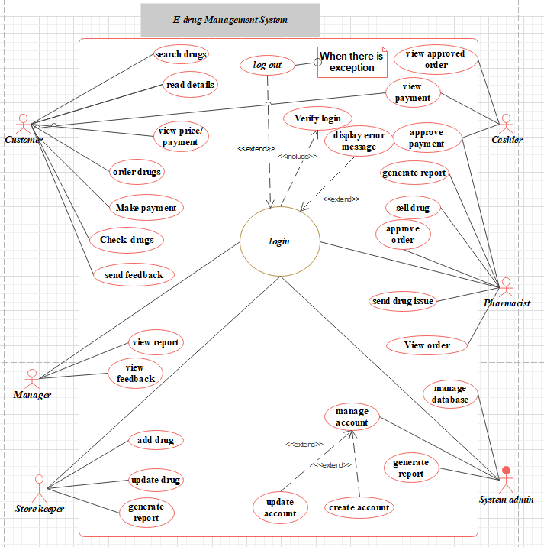

Figure 2.7.1: Use case Diagram



# Use Case Diagram Description

|  |  |  |
| --- | --- | --- |
| Use Case | Login | |
| Actor | Admin, Manager, Storekeeper, Pharmacist, Cashier, customer | |
| Goal | The user logins to the system. | |
| Precondition | The user should have an account in the system. Access the homepage of the drug store. | |
| Basic course of action | ***Actor actions*** | ***System responses*** |
|  | 1. The users click on the login link of the system homepage.  3. The user inserts user name and password privilege. | 2. The system displays the login form.  4. The system validates username and passwords.  5. The system displays the appropriate page. |
| Alternative course of action | If the user input is invalid the system promotes the user that the input is invalid. The system returns back to step 2. | |
| Post condition | The user is logged in the system and provided with privileges for actions according to their roles. | |

Table 2.8.1:Use case description for login

|  |  |  |
| --- | --- | --- |
| Use Case | Read drug detail | |
| Actor | Customer, pharmacist | |
| Goal | Customers read detailed information about drugs. | |
| Precondition | The user should access the website of the drug store through its URL and be at its homepage if he/she doesn't have an account, otherwise the user must login to the system first. | |
| Basic course of action | ***Actor actions*** | ***System responses*** |
|  | 1. Open main page  3. Clicks on service page  5. Click on drug information page  7. Enter drug name to search  8. Click on search | 2. Display homepage  4. Displays service page  6. Display drug information page  9. Validate data entered  System displays the drug name with a detailed explanation. |
| Alternative course of action | If the name of the drug entered is not valid, display invalid name message and redirect to step7. | |
| Post condition | Customers get the drug information in the system. | |

Table 2.8.2: Use case description of read detail description of drug

|  |  |  |
| --- | --- | --- |
| Use Case | Register drugs | |
| Actor | Storekeeper | |
| Goal | Make a register of drugs. | |
| Precondition | Storekeeper should log in to the system and register the required medicine. | |
| Basic course of action | ***Actor actions*** | ***System responses*** |
|  | 1. Click on homepage  3. Click on the service button.  5. Click on the register button.  7. Fill the register form. | 2. Display homepage.  4. Display service page  6. Display register form  8. Display successfully order |
| Alternative course of action | If you don’t order drug successfully, display you are not ordering drug and back to see step 7 | |
| Post condition | User register medicine successfully. | |

Table 2.8.3: Use case description for register drugs

|  |  |  |
| --- | --- | --- |
| Use Case | Update drugs | |
| Actor | Storekeeper | |
| Goal | Storekeeper update the information about drugs registered before | |
| Precondition | Storekeeper should login to the system to view the status of drugs. | |
| Basic course of action | ***Actor actions*** | ***System responses*** |
|  | 1. Click on storekeeper page  3. Click update drug to the system | 2. Display the stock status  4. Display added drug message |
| Post condition | Store keepers update drug information to the system. | |

Table 2.8.4: Use case description for Add drugs

|  |  |  |
| --- | --- | --- |
| Use Case | View report | |
| Actor | Cashier, pharmacist, storekeeper | |
| Goal | These above actors view reports about the overall functioning of the pharmacy. | |
| Precondition | They should first log to the system. | |
| Basic course of action | ***Actor actions*** | ***System responses*** |
|  | 1. Open the login page  3. Fill username and password  5. Click view report of drugs in the system | 2. Display enters username and password  4. Display view report page  6. Display the report |
| Alternate course of action | If you don’t enter the correct username and password, it is invalid account and you should back to step 3 | |
| Post condition | View details about reports on the system. | |

Table 2.8.5: Use case description for view report

|  |  |  |
| --- | --- | --- |
| Use Case | Send drug issue | |
| Actor | Store keeper | |
| Goal | Storekeepers send drug issues to pharmacist and manager. | |
| Precondition | Storekeeper should log in the system | |
| Basic course of action | ***Actor actions*** | ***System responses*** |
|  | 1. Open storekeeper page  3. Click on one of storekeeper link  4. Fill request form  6. Click send drug issue | 2. Display storekeeper page  5. Display sends drug issue  7. Display you sent the drug issue successfully. |
| Alternate condition | If the storekeeper doesn’t fill the request form properly the system sends an alert message not working properly and redirects to step 4. | |
| Post condition | Drug issue is sent to the pharmacy staffs. | |

Table 2.8.6: Use case description for send drug issue

|  |  |  |
| --- | --- | --- |
| Use Case | Accept/ reject/ reserve order | |
| Actor | Pharmacist | |
| Goal | Pharmacists view prescription paper customers. | |
| Precondition | Pharmacist should log in the system | |
| Basic course of action | ***Actor actions*** | ***System responses*** |
|  | 1. Open pharmacist page  3. Click view drugs detail | 2. Display prescription drugs  4. Display accept/ reject order  5. Display accept/ reject message successfully |
| Post condition | Accept/reject order of customer. | |

Table 2.8.7: Use case description for accept/reject order

|  |  |  |
| --- | --- | --- |
| Use Case | Approve Money | |
| Actor | Cashier | |
| Goal | Cashier accepts money from the customer based on drug value. | |
| Precondition | Cashier should log in the system | |
| Basic course of action | ***Actor actions*** | ***System responses*** |
|  | 1. Open cashier page  3. Click on send report button  5. write report approve/not money for drugs  6. click send report button | 2. Display cashier page  4. display the report address for writing |
| Post condition | Accept or reject order based on customer interest or based on customer’s pay or not for drug order. | |

Table 2.8.8: Use case description for accept money

|  |  |  |
| --- | --- | --- |
| Use case | Account management | |
| Actor | System Admin | |
| Goal | Admin to manage account i.e., create account, remove account, update account | |
| Precondition | Admin login to the system. | |
| Basic course of action | **Actor action** | **System response** |
|  | 1.Open admin page.  3.Click on manage account  5.Click create or update or remove account button | 2. Display Manage account.  4.Display create, update, remove account.  6.Display create/update/remove account successfully. |
| Alternative course of action | If the system does not create properly to users the admin creates an account on proper step, then back to step 5. | |
| Post condition | Admin Manage account. | |

Table 2.8.9: Use case description for manage account



# Sequence Diagrams

[UML](https://en.wikipedia.org/wiki/Unified_Modeling_Language) Sequence Diagrams are interaction diagrams that detail how operations are carried out. They capture the interaction between objects in the context of a collaboration. Sequence Diagrams are time focused and they show the order of the interaction visually by using the vertical axis of the diagram to represent time, what messages are sent and when.

**UML Sequence Diagrams Description**

* capture the interaction between objects in the context of a collaboration
* show object instances that play the roles defined in a collaboration
* show the order of the interaction visually by using the vertical axis of the diagram to represent time what messages are sent and when
* show elements as they interact over time, showing interactions or interaction instances

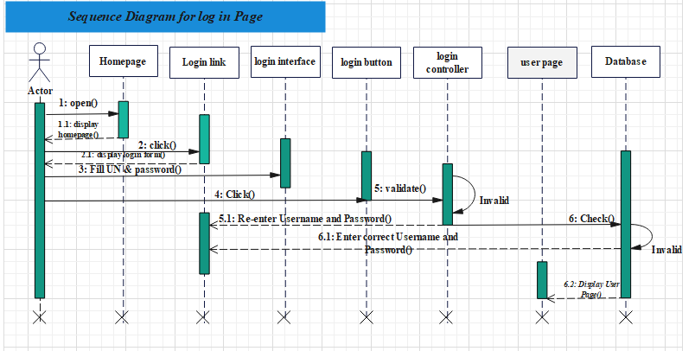

Figure 2.9.1: Sequence diagram for login page

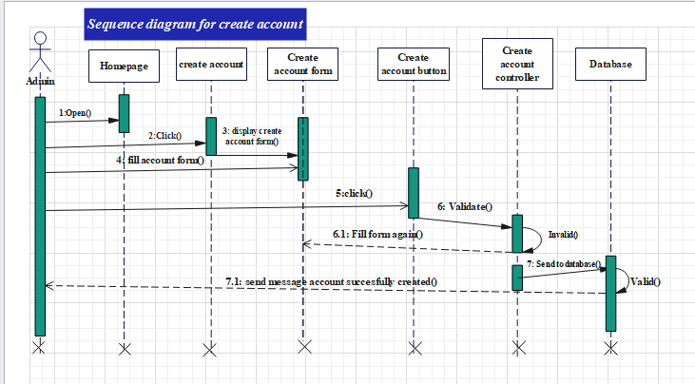

Figure 2.9.2: Sequence diagram for create account

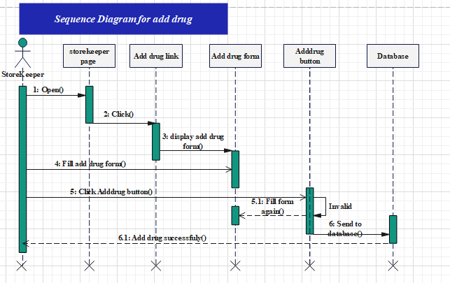

Figure 2.9.3: Sequence diagram for add drug

# Activity Diagrams

The Activity diagram gives more detail to a given use case and it often depicts the flow of information. Activity diagrams, which are related to program flow plans (flowcharts), are used to illustrate activities. In the external view, activity diagrams for the description of drug store management system processes that describe the functionality of the system. In activity diagrams, you use activity nodes and activity edges to model the flow of control and

data between actions.

The header of the activity frame displays the name of the activity, Activity1, and the body of the

activity frame displays the nodes and edges that describe the activity.

The following topics describe model elements in activity diagrams:

**Activities**

in UML, activities are container elements that describe the highest level of behavior in an

activity diagram. Activities contain several activity nodes and activity edges that

represent the sequence of tasks in a workflow that result in a behavior.

**Actions**

In UML, an action represents a discrete unit of functionality in an activity.

**Controls**

In activity diagrams, a control node is an abstract activity node that coordinates the flow

of control in an activity.

**Objects**

In activity diagrams, an object node is an abstract activity node that helps to define the

object flow in an activity.

**Activity edge**

In activity diagrams, an activity edge is a directed connection between two activity nodes.

When a specific action in an activity is complete, the activity edge continues the flow to

the next action in the sequence.

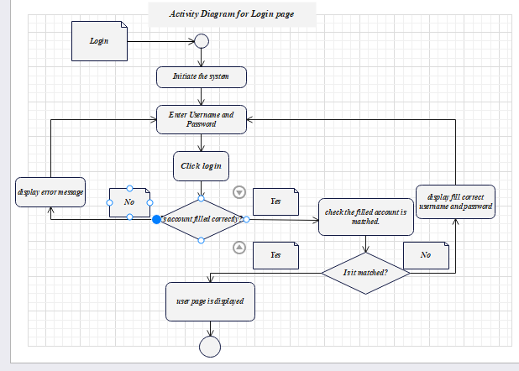

Figure 2.10.1: Activity diagram for login

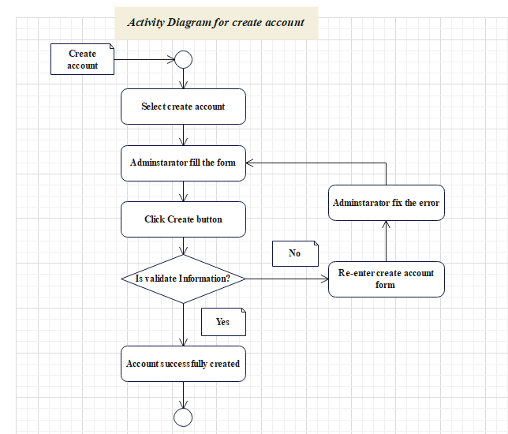

Figure 2.10.2: Activity diagram for create account

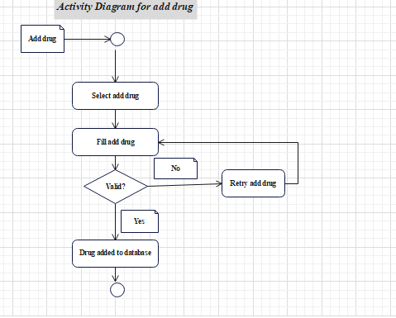

Figure 2.10.3: Activity diagram for add drug

# Analysis Class Diagram

Class models are the main study of object-oriented design and analysis. Class model shows the

classes of the system, their interrelationships (including inheritances, aggregation and

association) the operations and the attributes of classes. In this class diagram the team members

try to describe the types of objects in the system and the various kinds of static relationships that

exist among them as well as depicted the detailed understanding of problem domain of the

system. These Class diagrams are developed based on the functional requirement.

Show the classes of the system, their inter-relationships, and the operations and attributes of the

classes. Class diagrams are typically used, although not all at once, to:

* Analyze requirements in the form of a conceptual/analysis model
* Depict the detailed design of object-oriented or object-based software

Class Diagram provides an overview of the target system by describing the objects and classes

inside the system and the relationships between them. It provides a wide variety of usages; from

modeling the domain-specific data structure to detailed design of the target system. With the

share model facilities, you can reuse your class model in the interaction diagram for modeling

the detailed design of the dynamic behavior. The Form Diagram allows you to generate diagram

automatically with user-defined scope.

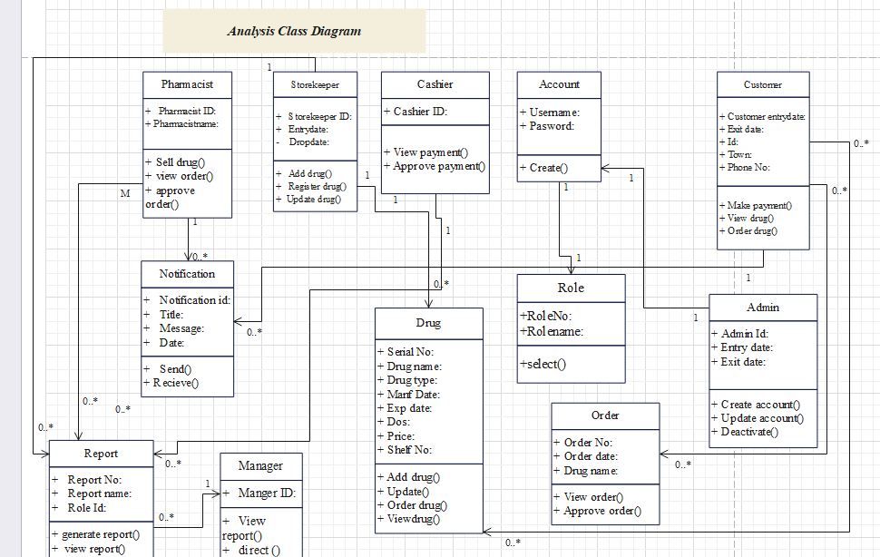

Figure 2.11.1: Analysis Class Diagram

# CHAPTER THREE



# SYSTEM DESIGN

System design is the process of defining the elements of a system such as the architecture,

modules and components, the different interfaces of those components and the data that goes

through that system. It is meant to satisfy specific needs and requirements of a business or

organization through the engineering of a coherent and well-running system.

System design has a great part which describes the first solution of the system problem. So

designing a system is an important and necessary step in any system. The main objectives of design to shows the direction how the system built and obtains clear

information needed to drive the actual implementation of the system.it is based on understanding

of the model the software built on. The objectives of the design are to model the system with

high quality. Implementing of high-quality system depend on the nature of design created by the

designer.

# Design Class Diagram

The class diagram is a static diagram. It represents the static view of an application. Class diagram is not only used for visualizing, describing and documenting different aspects of a system but also for constructing executable code of the software application. The class diagram describes the attributes and operations of a class on the pharmacy and the constraints imposed on the system of drug management. The class diagrams are widely used in the modeling of object-oriented systems because they are the only UML diagrams, which can be mapped directly with object-oriented languages. The class diagram shows a collection of classes, interfaces, associations, collaborations and constraints. It is also known as a structural diagram.

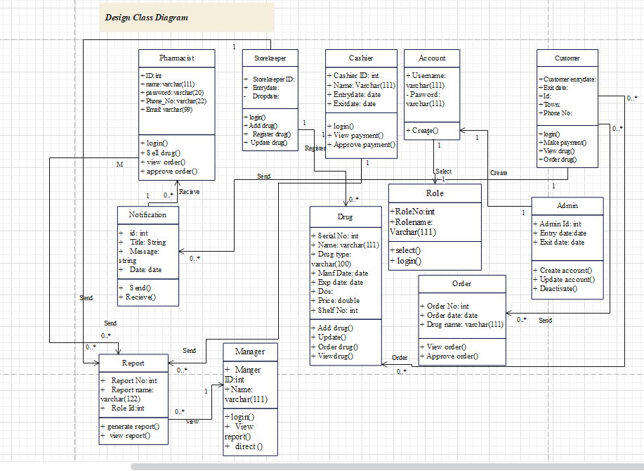

Figure 3.1.1: Design Class Diagram

# Physical Data Model

Physical database design translates the logical data model into a set of SQL statements that

define the database. For relational database systems, it is relatively easy to translate from a

Logical data model into a physical database.

Rules for translation:

✓ Entities become tables in the physical database.

✓ Attributes become columns in the physical database. Choose appropriate data type for

each of the columns.

✓ Unique identifiers are not allowed to have NULL values. These referred to as primary

keys in the physical database. Consider creating a unique index on the identifiers to

enforce uniqueness.

✓ Relationships are module as foreign keys

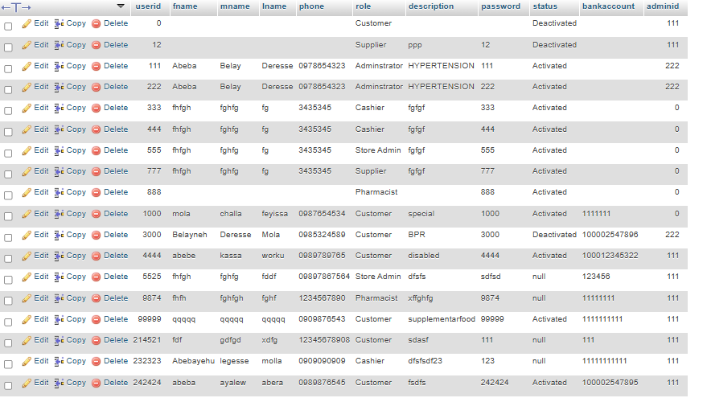

Figure 3.2.1: Physical database table of User

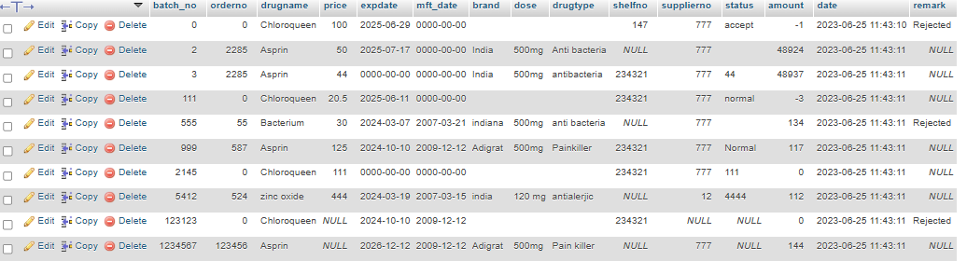

Figure 3.2.2: Detail of drug information on the database

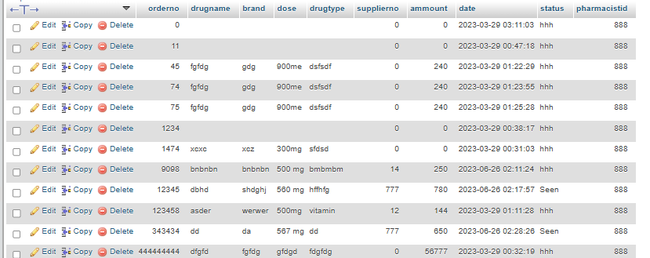

Figure 3.2.3: Order of drug and its database basics

# User Interface Design

The user interface (UI), in the industrial design field of human–computer interaction, is the space

where interactions between humans and machines occur. The goal of user interface design is to

produce a user interface which makes it easy (self-explanatory), efficient, and enjoyable (user-

friendly) to operate a machine in the way which produces the desired result. This generally

means that the operator needs to provide minimal input to achieve the desired output, and also

that the machine minimizes undesired outputs to the human.

User interface elements are the touchpoints users utilize to interact with the product. We will do the consideration of some elements to ease the using of system for users and pharmacists on convenience operation of tasks [5].

* Input controls
* Navigation components
* Information components
* Containers

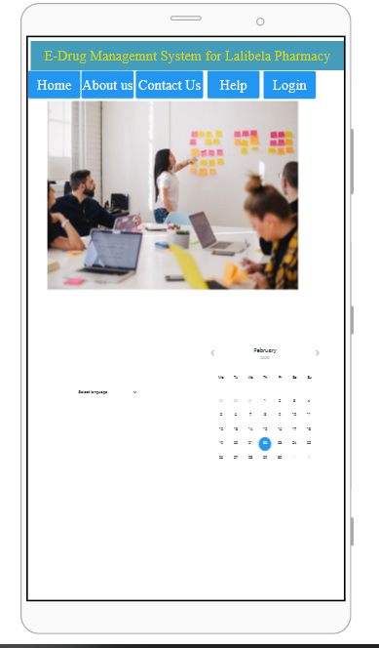

Figure 3.3.1: Homepage of User Interface Design

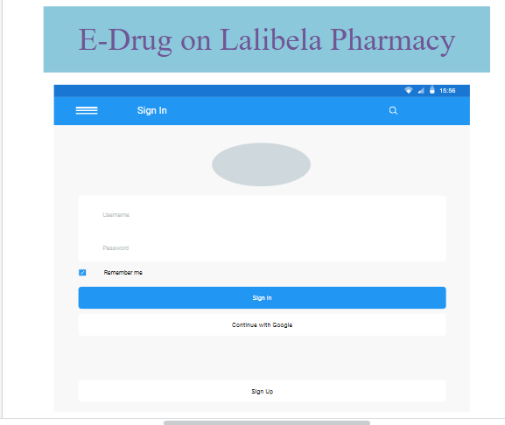

Figure 3.3.2: Login Page for Users

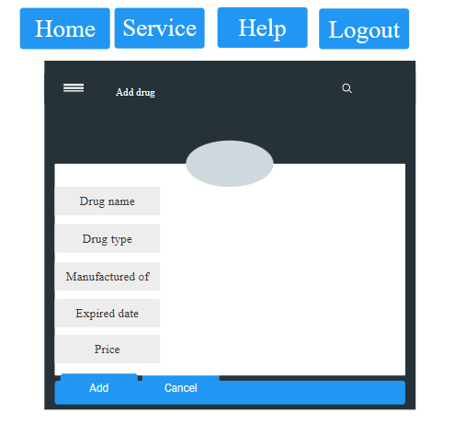

Figure 3.3.3: Add drug user interface on System

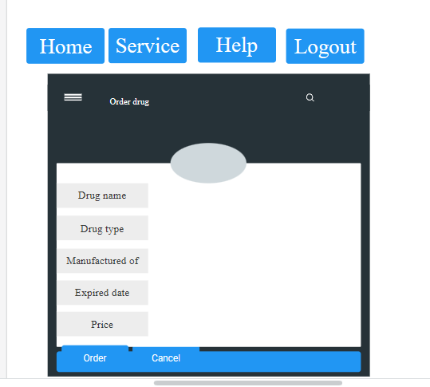

Figure 3.3.4: Order drug from pharmacy using browsers

# Deployment Diagram

A deployment diagram is a [UML diagram type](https://creately.com/lp/uml-diagram-tool) that shows the execution architecture of a system, including nodes such as hardware or software execution environments, and the middleware connecting them. Deployment diagrams are typically used to visualize the physical hardware and software of a system.

Deployment diagrams help model the hardware topology of a system compared to other [UML diagram](https://creately.com/lp/uml-diagram-tool) types which mostly outline the logical components of a system [6].

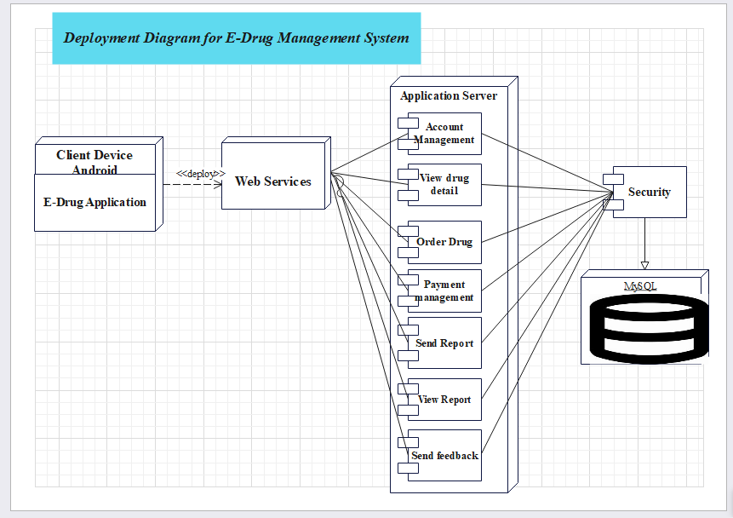

Figure 3.4.1: Deployment Diagram for E-Drug Management System

# References

|  |  |
| --- | --- |
| [1] | N. Muhammad, Drug Management System, Pahang: University Malaysia Pahang, 2010. |
| [2] | C. George, Hospital Pharmacy Management, 2012. |
| [3] | B. Spyropoulos, Incorprating the Internet of things in Modern Hospital, 2017, pp. 160-1669. |
| [4] | Ratsimbazafimshefa, F.Troulier Petal, Description and analysis of hospital pharmacies in Madagascar, vol. 76, 2018, pp. 218-227. |
| [5] | C. Raroque, "4 key elemnts to consider for every project on user interafce design," Aloa Blogger, 2021. [Online]. Available: https://aloa.co/blog/user-interface-design-4-key-elements-to-consider-for-every-project. |
| [6] | U. Ugochi, "Deployment Diagrams Explained in Detail, With Examples," Plutora, 4 August 2021. [Online]. Available: https://www.plutora.com/blog/deployment-diagrams-explained-in-detail-with-examples. |